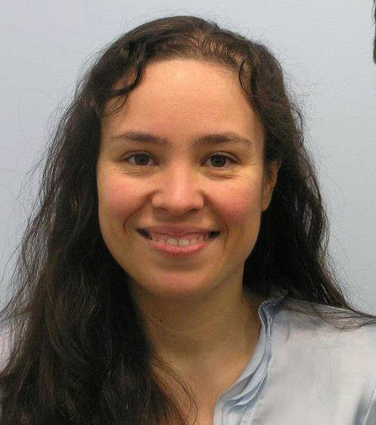
"The Protection at Conception Act establishes what science and what the Indiana Law Code has already affirmed: that life begins at conception. It is often argued by some that the unborn are not citizens and that they therefore have no rights, however we do not condone the wholesale murder of those living within our borders who do not possess citizenship.
When we meticulously protect the lives and rights of those who are the smallest of humans, we create a safer society for everyone. If the rights of our unborn sons and daughters are held firm it means that your rights and my rights are more substantial.
It has been rightly said that you can judge a person's strength by how he or she treats those who can do nothing for him or her. In standing up for the littlest children we are affirming that abortionists commit murder when they perform an abortion and that life – even from its earliest stages is precious and should be safeguarded.
The Protection at Conception Bill will close the gap that allows for the murder of 8,400 of our Hoosier sons and daughters each and every year."
- Rosa Hopkins – radio show host, recording artist, pro-life activist, blogger and writer for the Huffington Post-

